**Regression for BAE Systems**

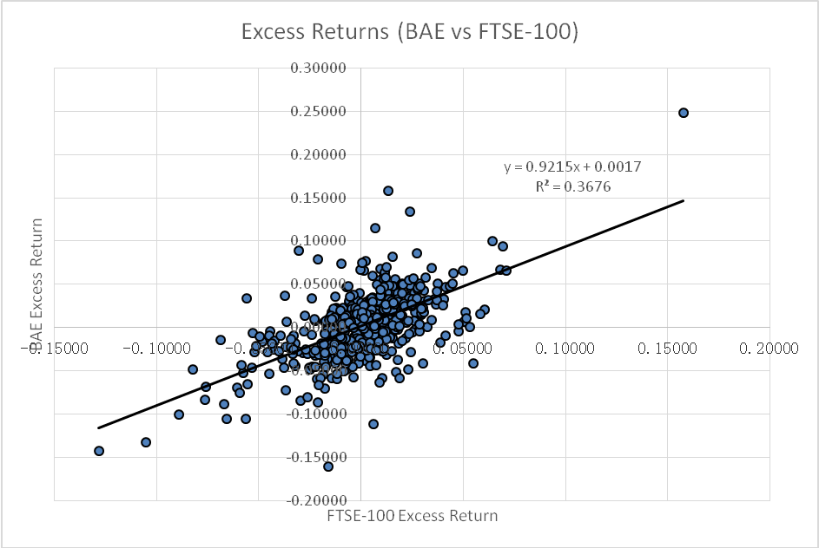

Figure 1: **BAE Systems Weekly Excess Returns against Market Weekly Excess Returns**

The regression results are given below:

BAE’s regression line expression:

y = 0.9215x + 0.0017 , R2 = 0.3676

BAE is over-performing than the market as the regression result suggests. This is because the regression line has the formula of

Ui   -   Rf   =   beta x ( Um - Rf )   +   alpha

where Ui corresponds to y and Um corresponds to x in the regression result. Alpha shows if the company is over-performing, or under-performing. According to the return indices, the average weekly return of government bond (risk free) is 0.00693 (0.69%). In this case, BAE has an Alpha of

Alpha = (y intercept)-(1-beta)*Rf

=0.0017-(1-0.9215)*0.00693

=0.001155995

This means that the company is over-performing to the market at a level of Alpha = 0.12% of excess return. In general, the shareholders of BAE systems will get an extra average of 0.12% compared to other investments.

As the Alpha of the regression is relatively small and insignificant in this case, while the Beta of the regression in larger than 0, we believe that the regression result of BAE is accepting CAPM model.

The sensitivity to the market is mainly determined by the Beta (β) in the formula. The gradient of this graph shows the variation of BAE returns against Market returns i.e the Beta (β), which is a quantification of the risk of a security. Hence, the (β) for BAE is 0.92 (3 s.f.). It can be seen from the graph, and the β value, that there is positive correlation between Market returns and BAE returns. This means that as the market rises (falls), BAE returns will rise (fall). However, BAE stock will rise and fall to a less extent than the market. Such a security is said to be defensive. To illustrate this, we will consider the following example. Suppose the market return premium rises by 10%, the return premium on BAE equity will rise by 9.2%. This result is expected, since the products of BAE are closely related to the general economic environment, but also supported by the government to prevent unstable changes to the company’s production. A fall in market conditions for example, will force BAE customers, such as airlines, to cut back on production, but the government as their main customer, their demand of products will remain comparatively stable, causing the return changing smaller than the general market.

Another feature of the regression results is R2, which represents systematic risk (the risk to the entire market) and is non-diversifiable. The value obtained is 0.3676 (3 s.f.). The maximum value of R2 is 1, indicating that the company acts exactly as predicted ( all the return data are located on the regression line) Hence, approximately 35.8% of the “riskiness” or the variation in returns of BAE stock is due to market variation, suggesting that BAE stock follows market conditions reasonably closely. The non-systematic or firm-specific risk is therefore given by 1-R2. 1-R2 = 1-0.368 = 0.632. Therefore, 63.2% of the riskiness of the firm is due to firm specific factors. This element of risk is diversifiable.

Position of SML: See discussion of the BAE’s position on SML in the following discussion along with Rolls-Royce’s position.

**Regression for Rolls-Royce**

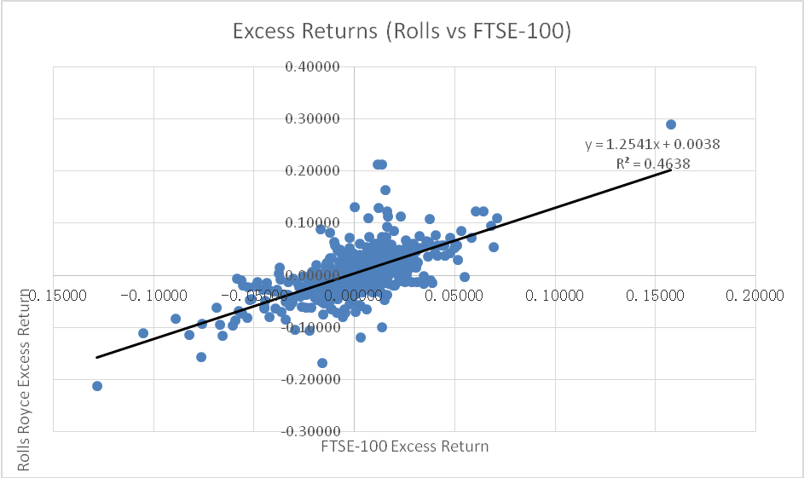

Figure 2: **Rolls-Royce Weekly Excess Returns against Market Weekly Excess Returns**

The regression results are given below:

Rolls-Royce’s regression line expression:

y = 1.2541x + 0.0038 , R2 = 0.4638

Rolls-Royce is over-performing than the market as the regression result suggests. This is because the regression line has the formula of

Ui   -   Rf   =   beta x ( Um - Rf )   +   alpha

According to the return indices, the average weekly return of government bond (risk free) is 0.00693 (0.69%). In this case, Rolls-Royce has an Alpha of

Alpha = (y intercept)-(1-beta)*Rf

=0.0038-(1-1.2541)*0.00693

=0.005560913

This means that the company is over-performing to the market at a level of Alpha = 0.56% of excess return. In general, the shareholders of Rolls-Royce systems will get an extra average of 0.56% compared to other investments.

The gradient of this graph shows the variation of Rolls-Royce returns against Market returns i.e the Beta (β), which is a quantification of the risk of a security. Hence, the (β) for Rolls-Royce is 1.25 (3 s.f.). It can be seen from the graph, and the β value, that there is positive correlation between Market returns and Rolls-Royce returns. This means that as the market rises (falls), Rolls-Royce returns will rise (fall). However, Rolls-Royce stock will rise and fall to a greater extent than the market. Such a security is said to be aggressive. To illustrate this, we will consider the following example. Suppose the market return premium rises by 10%, the return premium on Rolls-Royce equity will rise by 12.5%. This result is expected, since the products of Rolls-Royce are not strictly a necessity. A fall in market conditions for example, will force Rolls-Royce customers, such as airlines, to cut back on production, meaning Rolls-Royce is forced to reduce output and therefore profits.

Another feature of the regression results is R2, which represents systematic risk (the risk to the entire market) and is non-diversifiable. The value obtained is 0.463 (3 s.f.). Hence, approximately 46.3% of the “riskiness” or the variation in returns of Rolls-Royce stock is due to market variation, suggesting that Rolls-Royce stock follows market conditions reasonably closely. The non-systematic or firm-specific risk is therefore given by 1-R2. 1-R2 = 1-0.463 = 0.537. Therefore, 53.7% of the riskiness of the firm is due to firm specific factors. This element of risk is diversifiable.

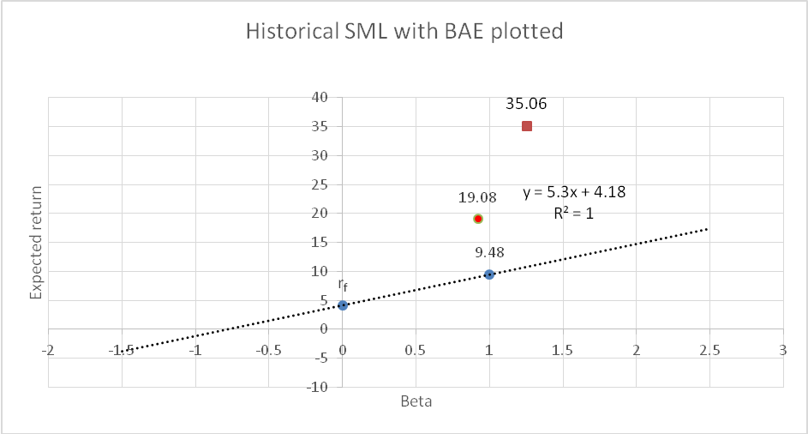

**Figure 3: Rolls-Royce and BAE Systems position on the historical Security Market Line (SML)**

The round dot on the graph represents BAE System’s expected yearly return, and it is clearly situated above the SML. This means the stock is over performing, since the return is greater than would be predicted based on the risk associated with the stock. Therefore, the stock is under-priced.

The square on the graph represents Rolls-Royce expected yearly return, and it is clearly situated above the SML. This means the stock is over performing, since the return is greater than would be predicted based on the risk associated with the stock. Therefore, the stock is under-priced.

The level of over-performance is illustrated by the Alpha value of the regression analysis, and also the position of the two companies on the SML. It is clear that the level of over-performance of Rolls-Royce is more than twice than BEA systems.